DAY 6 - DEPLOYMENT PREPARATION AND STAGING ENVIRONMENT SETUP

"Deployment Preparation and Staging Environment Setup" with two main sections:

1. Deployment Details:

* Hosting Platform: Vercel
* Repository Link on GitHub
* Staging URL using Vercel

1. Environment Setup Process:

* Hosting Platform Setup
  + Selected Vercel as the hosting platform
  + Connected GitHub repository to Vercel
  + Configured build settings and secure environment variables
* Environment Variables:
  + Created a .env file with three key variables:
    - NEXT_PUBLIC_SANITY_PROJECT_ID (for Sanity project identifier)
    - NEXT_PUBLIC_SANITY_DATASET (for production dataset name)
    - API_KEY (for third-party services)
  + These variables were securely uploaded to Vercel.

DEPLOYMENT PROCESS: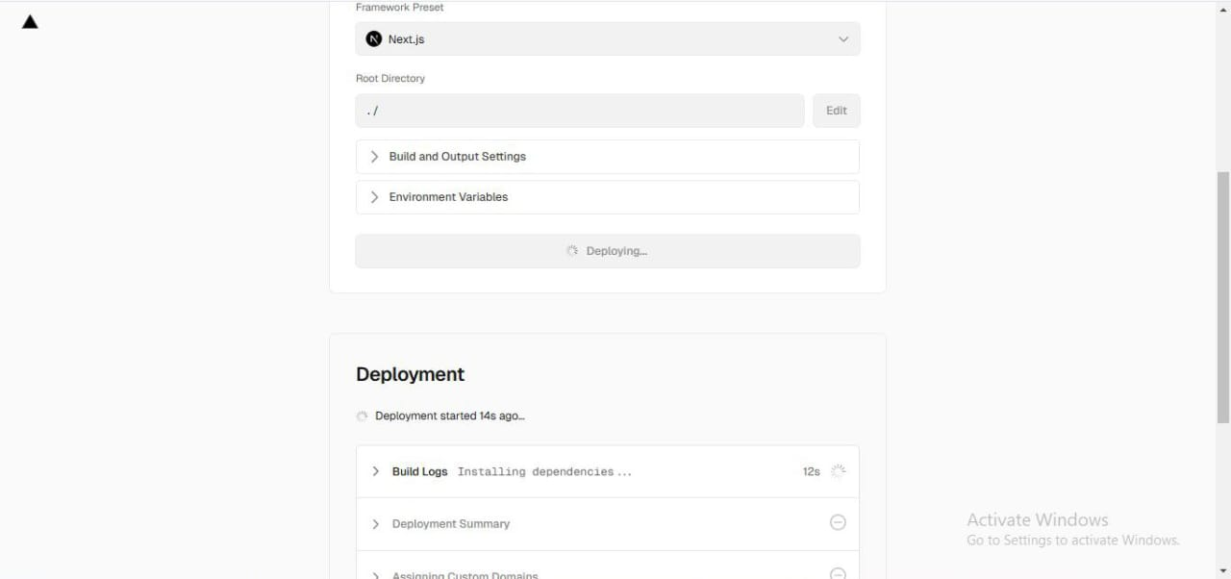

DESKTOP TESTING:

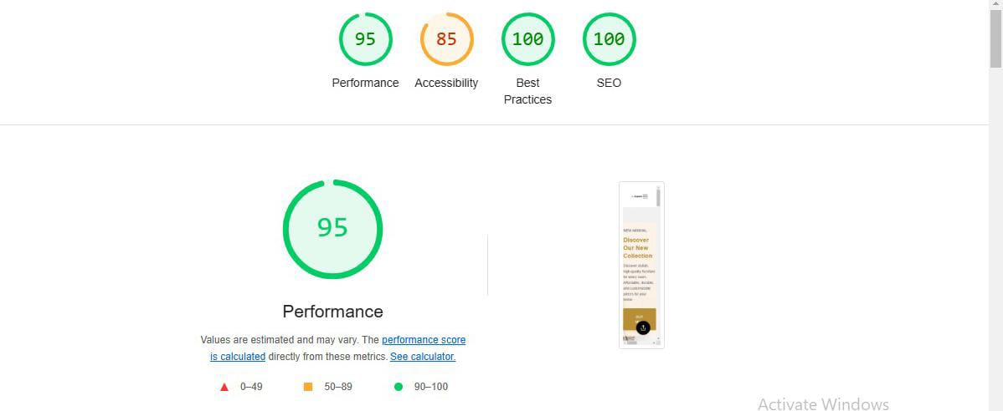

M